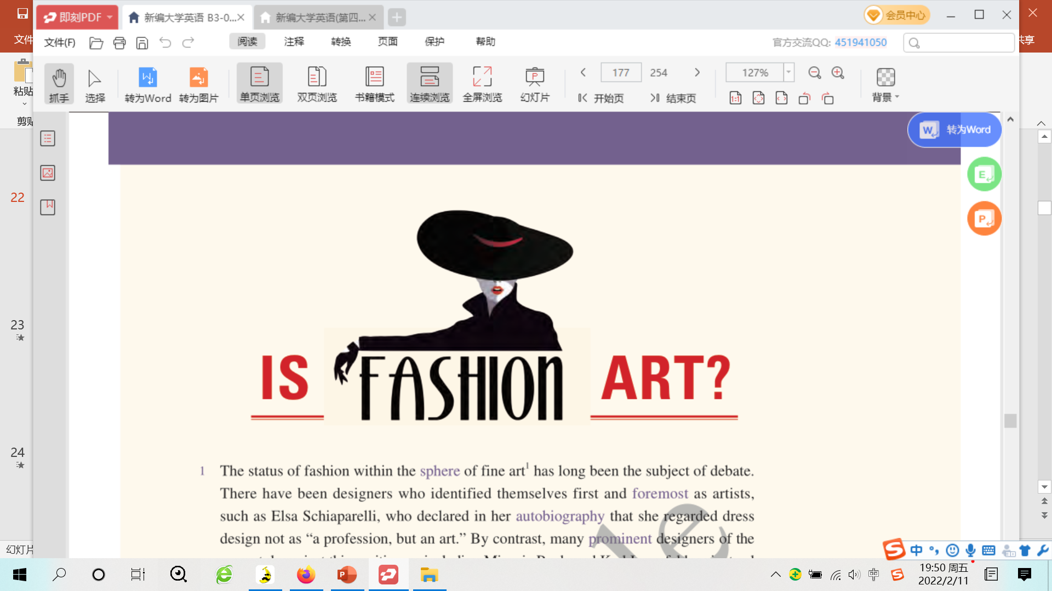

建议使用方法：因为文章有难度，可以选择一开始就做听力练习。或者等完全学完文章以后，自己先填写（很有挑战性哈--错一大堆也是正常的话）。然后再听，或者直接核对答案。

[1] ***The status of fashion _________________________________ of fine art has long been the ____________________________.*** There have been designers who ***identified themselves ____________________________ as artists***, such as Elsa Schiaparelli, who declared in her ***___________________***that she regarded dress design not as "a profession, but an art." By contrast, many ***______________***designers of the present day reject this position — including Miuccia Prada and Karl Lagerfeld — instead ***______________fashion and art as their own separate, ____________________________, ______________***. In fact, Yves Saint Laurent believed there to be such a large gap between the two fields that he once ***______________***that, despite his ***______________________ achievements*** as a fashion designer, "I am ***a ______________painter.***"

[2] In 1983, this ***______________***dispute was ***brought to the ______________of art ______________and scholarship*** when The Metropolitan Museum of Art's Costume Institute held an exhibition of Saint Laurent's designs. Displaying the ***______________clothes*** ***in the same manner and context*** as ***______________***by Picasso and Monet angered many critics, who were forced to question ***whether an "applied" or "______________" art should be ______________to the same ______________as fine art.***

[3] From one point of view, ***the main differences*** between fashion and art ***could be found in their ______________and ______________***. Fashion is ***______________by certain factors***, including ***wearability and the specific ______________of the human body***, for instance. It has a clear commercial value, ***priced as a ____________________________ of the cost of goods and ____________________________***. Fashion is ***____________________________,*** frequently changing based on trends. Those considerations, one could argue, ***keep fashion ______________from art***, in which economic considerations in general are seen as much less important — art is created ***______________________ its economic value.*** And the nonutility of art is a key factor that ***______________ it from fashion,*** as is the fact that its value increases over time.

[4] However, in the real art world — and ***in the most ____________________________ corners of fashion*** — ***these ______________have never been so ____________________________,*** and today they're ***______________ being ______________.*** Fashion designers like Rei Kawakubo have ***______________against the ______________***of the human body, cutting clothes with unnatural shapes that ***suggest ______________physical possibilities.*** Fashion has ***____________________***dominated fine art museums: The ***______________***Museum of Art's 2011 ***____________________***"Alexander McQueen: Savage Beauty" was one of the most popular and ***____________________________*** exhibitions in the museum's history. And anyone who doesn't believe that the most significant designer clothes do increase in value has never attended a fashion auction, such as last November's Vintage Couture sale at Christie's, London, where a 1939 black ***______________***evening jacket by Schiaparelli was sold for $117, 200.

[5] Just as fashion is ***______________*** art, art, too, is ***_____________ _adopting __________________________________________________________***. As art economist Clare McAndrew noted in her book *The Art Economy*, "no matter how ***______________***art is in society, there is no e***_____________*** the fact that it is produced, bought, and sold by individuals and ***________________________ working within an economic _____________ _____________ from material and market _____________ ,***" a fact that is mainly ***a _____________ of an _____________ global art market***. Artists today have become brand names, with many investors looking less at the ***_____________ or formal qualities*** of an artwork and instead examining an artist's sales history and "***__________________________***." They just look at each piece of art as an investment in the same way someone might buy stocks and shares in a company.

***[6] _____________,*** many contemporary artists have made art's ***function as a __________________________*** a ***_____________***aspect of their work. ***_____________their __________________________,*** artists have often ***_____________with fashion designers*** to ***create __________________________ clothing _____________***, such as Murakami's Louis Vuitton bags. And anyone who doesn't believe that art follows trends has never ***____________________________________,*** where ***common approaches to a _____________opening in art history*** often lead to ***a ________________ of similar objects*** made by artists all over the world.

[7] Considering the ***____________________________________________*** of the ***art and fashion ______________________***— particularly over the past 50 years — ***the ______________________***between fashion and art ***__________________________________*** become almost ***_________________***. So ... fashion is clearly art, right? Well, in my view, not quite. Fashion and art share more of ***a _________________relationship***, as ***two different means of __________________________________ that profit from frequent _________________.*** There is no doubt that ***fashion __________________________________ in the museum***, and should be valued for its ***contribution to our __________________________________.*** ***Fashion shows today are so _________________and _________________***that it's difficult not to consider them a form of ***performance art.*** I could not argue against anyone who said that certain styles from ***avant-garde designers*** like Alexander McQueen are true works of art.

[8] Yet, the ***_________________difference*** between fashion and art ***remains***,***__________________________________*** — just as there is a distinction between design, where an object is created to ***fulfill a functional need,*** and art, where ***artworks _________________ fulfill non-functional (_________________, for instance) needs***. There's a reason fashion designers are called "designers," after all. However, Karl Lagerfeld may have ***__________________________________*** when he said how closely connected the two are: "Art is art. Fashion is fashion. However, Andy Warhol proved that they can exist together."

参考答案

[1] ***The status of fashion within the sphere of fine art has long been the subject of debate.*** There have been designers who ***identified themselves first and foremost as artists***, such as Elsa Schiaparelli, who declared in her ***autobiography*** that she regarded dress design not as "a profession, but an art." By contrast, many ***prominent*** designers of the present day reject this position — including Miuccia Prada and Karl Lagerfeld — instead ***viewing fashion and art as their own separate, if highly complementary, realms***. In fact, Yves Saint Laurent believed there to be such a large gap between the two fields that he once ***lamented*** that, despite his ***legendary achievements*** as a fashion designer, "I am ***a failed painter.***"

[2] In 1983, this ***occasional*** dispute was ***brought to the forefront of art criticism and scholarship*** when The Metropolitan Museum of Art's Costume Institute held an exhibition of Saint Laurent's designs. Displaying the ***iconic clothes*** ***in the same manner and context*** as ***masterpieces*** by Picasso and Monet angered many critics, who were forced to question ***whether an "applied" or "decorative" art should be elevated to the same platform as fine art.***

[3] From one point of view, ***the main differences*** between fashion and art ***could be found in their utility and temporality***. Fashion is ***constrained by certain factors***, including ***wearability and the specific contours of the human body***, for instance. It has a clear commercial value, ***priced as a cross-function of the cost of goods and brand perception***. Fashion is ***ever-evolving,*** frequently changing based on trends. Those considerations, one could argue, ***keep fashion distinct from art***, in which economic considerations in general are seen as much less important — art is created ***regardless of its economic value.*** And the nonutility of art is a key factor that ***differentiates it from fashion,*** as is the fact that its value increases over time.

[4] However, in the real art world — and ***in the most avant-garde corners of fashion*** — ***these distinctions have never been so clear-cut,*** and today they're ***increasingly being blurred.*** Fashion designers like Rei Kawakubo have ***rebelled against the format*** of the human body, cutting clothes with unnatural shapes that ***suggest alternative physical possibilities.*** Fashion has ***increasingly*** dominated fine art museums: The ***Metropolitan*** Museum of Art's 2011 ***retrospective*** "Alexander McQueen: Savage Beauty" was one of the most popular and ***widely attended*** exhibitions in the museum's history. And anyone who doesn't believe that the most significant designer clothes do increase in value has never attended a fashion auction, such as last November's Vintage Couture sale at Christie's, London, where a 1939 black ***velvet*** evening jacket by Schiaparelli was sold for $117, 200.

[5] Just as fashion is ***following*** art, art, too, is ***steadily adopting characteristics typical of fashion***. As art economist Clare McAndrew noted in her book *The Art Economy*, "no matter how ***highly valued*** art is in society, there is no ***escaping*** the fact that it is produced, bought, and sold by individuals and institutions ***working within an economic framework inescapable from material and market constraints,***" a fact that is mainly ***a byproduct of an increasingly global art market***. Artists today have become brand names, with many investors looking less at the ***aesthetic or formal qualities*** of an artwork and instead examining an artist's sales history and ***"brand value.***" They just look at each piece of art as an investment in the same way someone might buy stocks and shares in a company.

***[6] In turn,*** many contemporary artists have made art's ***function as a market commodity*** a ***core*** aspect of their work. ***Leveraging their brand identities,*** artists have often ***partnered with fashion designers*** to ***create wildly popular clothing collaborations***, such as Murakami's Louis Vuitton bags. And anyone who doesn't believe that art follows trends has never ***toured an art fair,*** where ***common approaches to a perceived opening in art history*** often lead to ***a profusion of similar objects*** made by artists all over the world.

[7] Considering the ***changing dynamics*** of the ***art and fashion worlds*** — particularly over the past 50 years — ***the distinctions*** between fashion and art ***in the traditional sense*** become almost ***nonexistent***. So ... fashion is clearly art, right? Well, in my view, not quite. Fashion and art share more of ***a symbiotic relationship***, as ***two different means of creative self-expression that profit from frequent interchange.*** There is no doubt that ***fashion demands a rightful place in the museum***, and should be valued for its ***contribution to our visual culture.*** ***Fashion shows today are so elaborate and conceptual*** that it's difficult not to consider them a form of ***performance art.*** I could not argue against anyone who said that certain styles from ***avant-garde designers*** like Alexander McQueen are true works of art.

[8] Yet, the ***intrinsic difference*** between fashion and art ***remains***, ***in terms of utility*** — just as there is a distinction between design, where an object is created to ***fulfill a functional need,*** and art, where ***artworks largely fulfill non-functional (spiritual, for instance) needs***. There's a reason fashion designers are called "designers," after all. However, Karl Lagerfeld may have ***put it best*** when he said how closely connected the two are: "Art is art. Fashion is fashion. However, Andy Warhol proved that they can exist together."